30. Flinn and Hsü Diagram

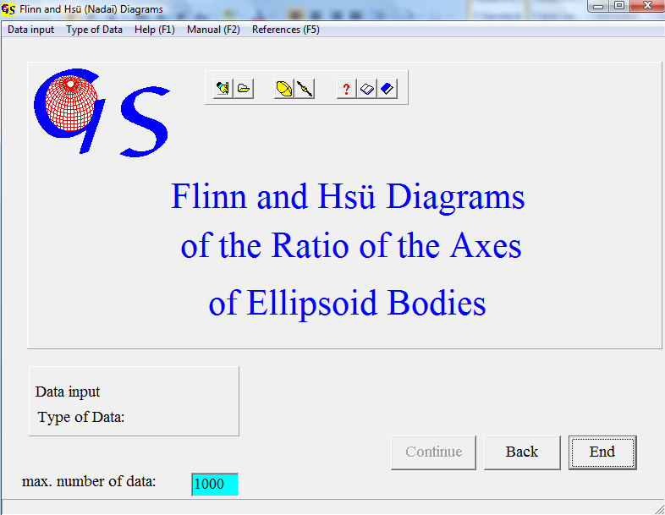
Fig. 1

This program (Fig. 1) plots the ratios of the principal axes of a strain ellipsoid. Data input can either be manual or from a file (Fig. 2).

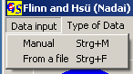
Fig. 2

Data can be either the axes or the three principal elongations (e₁, e₂ and e₃ in percent) of ellipsoids . Click on 'Axes' or 'Elongation' in menu “Type of data” (Fig. 3).

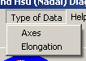
Abb. 3

After the choice has been completed in these two menus, the button “Continue” becomes active. This button opens the next form.

Fig. 4 shows the form for manual input of axes after pressing the 'Start' button and after data input.

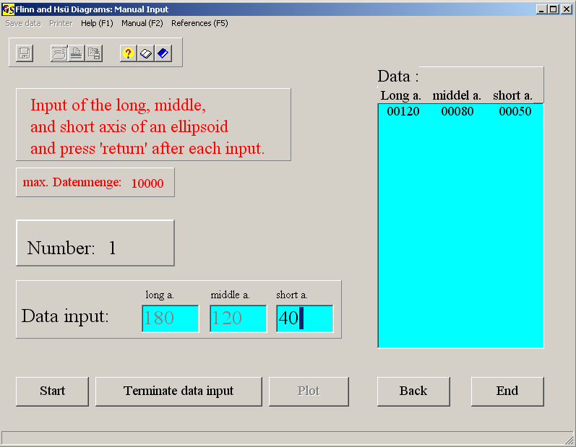
Fig. 4

Input of each axis is terminated by “Enter”. After input of one set of data this set appears in the list on the right side of the form. Only integer numbers are accepted. Fig. 5 shows the form for input of elongations.
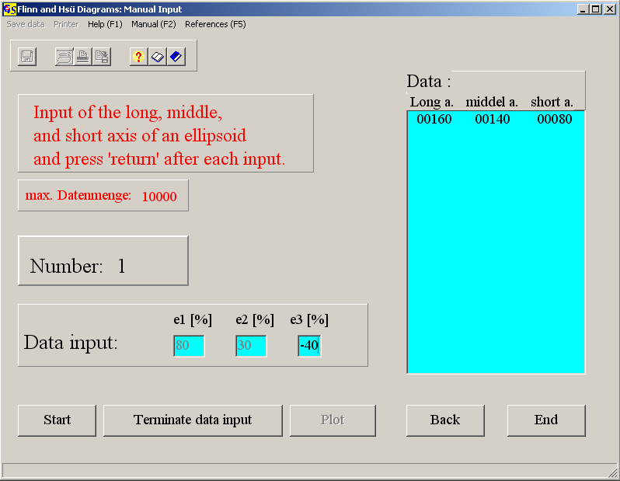
Abb. 5

The elongations e₁, e₂, e₃ (e = (deformed length – undeformed length) / un-deformed length)) are measured parallel to the principal axes X > Y > Z of a strain ellipsoid. Input is in integer numbers. e₃ is always negative.

For both types of data input must be terminated by pressing the button 'Terminate data input'. Now the menus “Save data” and “Printer” become active. Both types of data are saved as axes (example: the data set e₁ = 40%, e₂ = 20%, e₃ = -20% is saved as 140, 120, 80). The button “Plot” opens the form for the diagrams (Fig. 6).

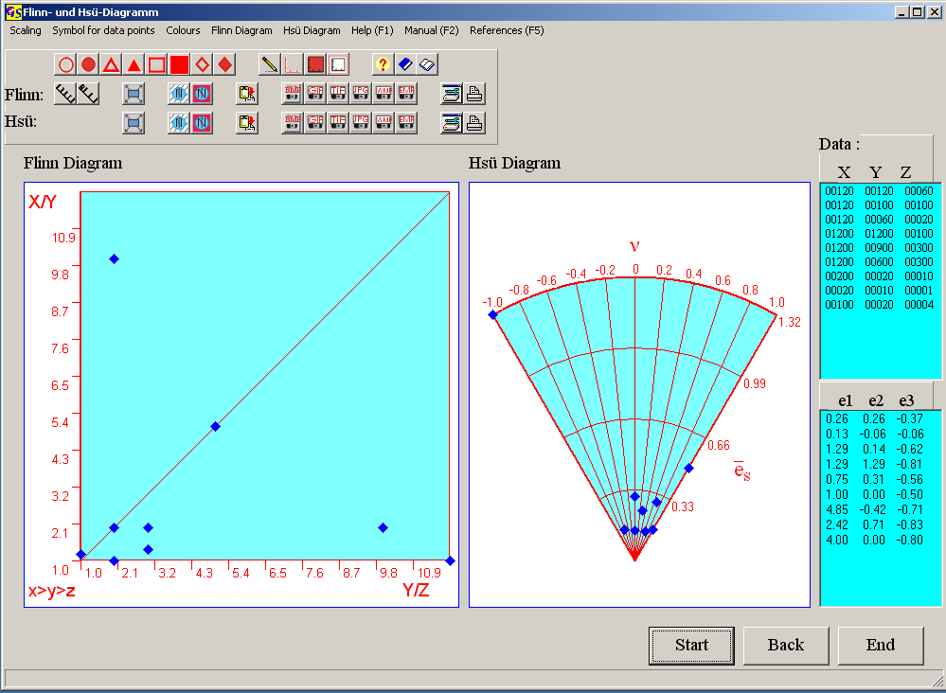
Abb. 6

Flinn Diagram (Flinn, 1962): The y-axis is the ratio a = X / Y, and the x-axis is b = Y / Z. The k-value

k = (a-1) / (b – 1)

describes the shape of an ellipsoid. k = ∞ represents a prolate (uniaxial extension) ellipsoid (Fig. 7). Prolate shapes plot on the y-axis. k = 0 represents an oblate (uniaxial shortening) ellipsoid (Fig. 8). Oblate shapes plot on the x-axis. k = 1 represents plane strain (Fig.9). In this deformation the Y-axis of the ellipsoid is unchanged.
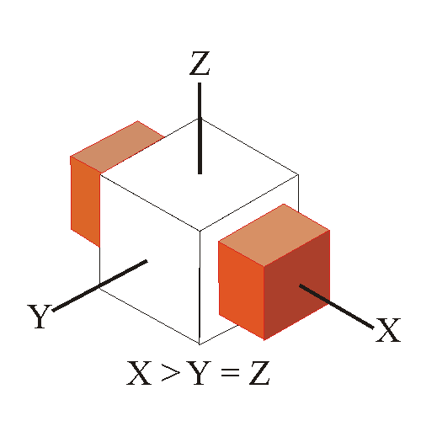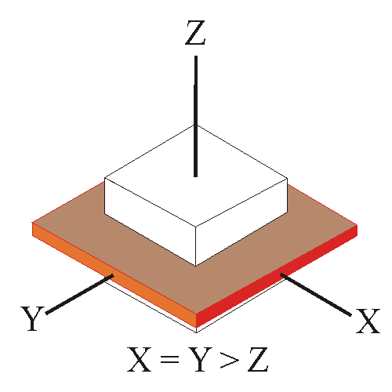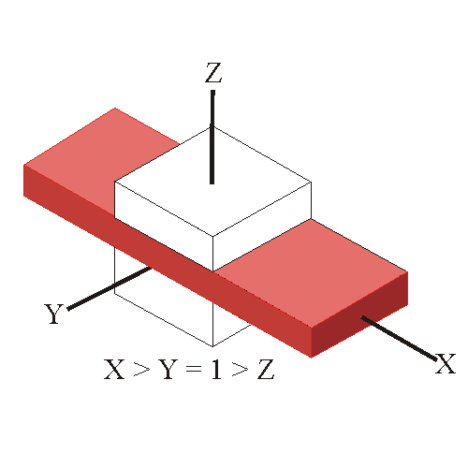
Fig. 7 Fig. 8 Fig. 9

Hsü (Nadai) Diagram (Hsü, 1966; Nadai, 1963): This diagram uses the Lode parameter

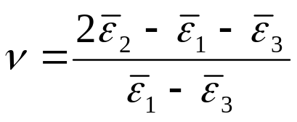.

instead of the k-value. 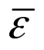 is the natural strain (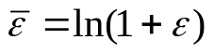). ν is in the range between –1 (prolate) and 1 (oblate). ν = 0 represents plane strain. The intensity of deformation, derived from the amount of work necessary to distort a sphere from (ε_{s} = 0) to a final shape (ε_{s} > 0) is marked on the Lode parameter. It is called the finite strain parameter

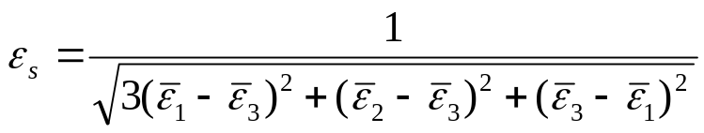.

Choice of colours and changes of the shape of data points and savings of the graphic are the same as in all other programs.
Input of data from a file is also the same as in all other programs.

